Press Release
Media Contacts:
IB Communications
exmoor@ibcomms.agency

eXmoor Pharma and UCL forge a strategic collaboration to speed the advancement of cell and gene therapies
Bristol and London, UK, 2 December 2025 - eXmoor Pharma, the UK’s only fully integrated cell and gene therapy CDMO with embedded consultancy expertise, and the Translational Research Office (TRO) at University College London (UCL) have formed a strategic collaboration to accelerate the development of novel cell and gene therapies (CGTs) from academic research into clinical application.
The collaboration will support earlier and more efficient engagement between UCL innovators and eXmoor’s multidisciplinary teams, helping to reduce the risk, cost and complexity of technology development. By combining the TRO’s translational research expertise with eXmoor’s consultancy, development and Good Manufacturing Practice (GMP) capabilities, the collaboration aims to create faster and more effective routes to clinical trial readiness and beyond.
A shared focus on strategic, scalable translation
UCL and eXmoor share a commitment to overcoming the technical and regulatory challenges that often delay promising CGT candidates. Through this relationship, academic teams will gain early access to:
- CMC consulting and regulatory strategy support
- Laboratory capacity and expertise in process and analytical development
- GMP manufacturing for early clinical studies
- Cross-modality insight across viral vectors, autologous and allogeneic cell therapies, and RNA technologies
Through this collaboration, UCL researchers will benefit from structured early engagement with eXmoor’s expert teams, which will help shape more practical and commercially aware development strategies. This includes opportunities for grant input, regular consultancy clinics, and joint events, all designed to bridge the gap between academic innovation and GMP readiness.
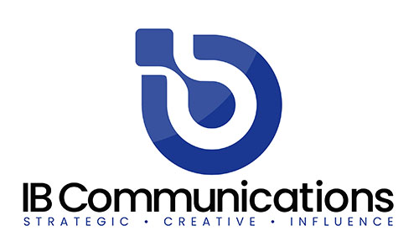
eXmoor will benefit from direct collaboration with UCL’s translational researchers, enabling its teams to stay at the forefront of technological innovation and evolving CGT modalities. By working together from the earliest stages of development, eXmoor can align its capabilities with emerging innovations and foster scalable, GMP-ready solutions that reflect real clinical and commercial potential.
Angela Osborne, Founder & Executive Chair of eXmoor Pharma, commented:
“The strength of the UK’s academic science has always been clear but getting groundbreaking therapies from the lab to patients requires a collaborative approach. This partnership with UCL TRO reflects our shared belief that supporting translational research with practical, GMP-ready solutions is the key to unlocking meaningful outcomes for patients. We’re pleased to play a role in helping academic innovation become clinical reality.”
Pamela Tranter, Head of the Translational Research Group at UCL Translational Research Office, said:
“UCL is committed to driving innovation that transforms lives, with a world-leading pipeline of Advanced Therapy Medicinal Products (ATMPs). Through this strategic partnership, we look forward to connecting UCL researchers with eXmoor’s expertise, supporting closer collaboration with industry and the development of practical, scalable plans that could help realise therapeutic potential."
About eXmoor Pharma
eXmoor Pharma is the only integrated cell and gene therapy CDMO with over 20 years of consultancy expertise embedded at every stage of development. From early-phase strategy and process development to GMP manufacturing and commercialisation, eXmoor supports clients with deep technical knowledge, regulatory insight and flexible manufacturing solutions. With a purpose-built facility in Bristol, UK, and over 170 clients globally, eXmoor is a trusted partner for cell and gene therapy innovators looking to scale their therapies safely and efficiently.

About UCL Translational Research Office
The UCL Translational Research Office (TRO) is an integral part of UCL’s established biomedical research ecosystem, supporting the translation of UCL’s world-class biomedical research into new therapies, diagnostics and medical devices that deliver patient benefit. Working in partnership with researchers and external collaborators, the TRO provides specialist knowledge to help advance discoveries along the development pathway and accelerate their journey from lab to market.

