Press Release
Media Contact:
IB Communcations
organabio@ibcomms.agency

OrganaBio Continues Global Access Expansion through Distribution Partnership with Bio-Connect

Partnership expands reach of OrganaBio’s ethically sourced perinatal and peripheral blood-derived materials for drug development

Researchers gain local support for sourcing, cell processing, and delivery services

Miami, FL, June 17, 2026 — OrganaBio, LLC ("OrganaBio"), a manufacturer of Research- and cGMP-grade cells and blood-derived products and provider of cell isolation and cryopreservation services, has established a non-exclusive distribution partnership with Bio-Connect to extend access to ethically sourced perinatal and peripheral blood-derived cellular materials for researchers across the Benelux region.

Through the partnership, researchers and developers in Belgium, the Netherlands, and Luxembourg will have streamlined access to cord blood, placental and umbilical cord tissue, apheresis leukopaks, and primary cell products including HSCs, PBMCs, and other immune cell subsets.

The collaboration combines OrganaBio’s donor network, logistics capabilities, and cell processing expertise with Bio-Connect’s regional presence and customer support. Services available through the partnership include custom cell isolation, expansion, cryopreservation, and characterization to support research and development programs.

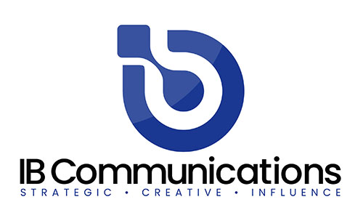
“Bio-Connect is a key regional partner for us in Europe as we continue to expand our global reach to new regions, helping make our ethically sourced cellular materials for research more accessible in more places,” said Carlos Carballosa, co-founder and Vice President of Sales, OrganaBio.

The agreement is designed to help life sciences organizations obtain high-quality cellular materials with reliable delivery and technical support, enabling continuity across a range of research and translational applications.

About OrganaBio
OrganaBio, LLC is a vertically integrated cell therapy contract development and manufacturing organization (CTDMO) headquartered in Miami, Florida, with cGMP manufacturing and cell processing facilities in Miami and San Diego and regional cell processing labs in San Francisco and Irvine. Through its wholly owned, FDA-registered subsidiaries – HemaCenter, LLC (adult leukapheresis) and GaiaGift, LLC (birth tissue and cord blood) – OrganaBio operates proprietary supply chains for ethically sourced human tissues and blood-derived cellular products. The combined platform delivers GMP isolated cells, clinical-sample processing including PBMC isolation, cell isolation and cryopreservation services, cGMP manufacturing for autologous and allogeneic cell therapies, process development, analytical testing, quality assurance, and regulatory support under a single quality framework, enabling cell therapy developers to accelerate the path from development to patient. For more information, visit www.organabio.com.

