Press Release
Media Contacts:
IB Communications
Tel +44 (0)20 89434685
ISCT@ibcomms.agency

ISCT 2023 Paris harnessing global expertise and enabling collaboration to drive advanced therapies to patients

Vancouver, Canada, April 3, 2023 - The International Society for Cell & Gene Therapy (ISCT), the global society of over 3000 members dedicated to the translation of cell and gene therapies (CGT) into safe and effective treatments to improve patient lives, today announces it will host the largest translation-focused event connecting academic, regulatory and industry experts from around the world to collaborate and find tangible solutions to the most critical issues affecting the development of advanced therapies.

The peer-curated ISCT 2023 program will be held in person at the Paris Convention Center in Paris, France, between May 31-June 3, 2023. Under the theme ‘Celebrating the Progress of Advanced Therapies, Building the Future Through Translation’, the meeting will bring together over 2000 international delegates to collaborate and engage on the latest challenges, advancements, and breakthroughs in the industry.

Commenting on the upcoming 29th ISCT annual meeting, Jacques Galipeau MD, ISCT President said, “What truly makes ISCT meetings unique is our ability to connect cell and gene professionals from across the globe and create pragmatic and actionable solutions not just for our members but for the sector as a whole. Our meetings are the intersection where key players from academia, industry and regulatory connect with the focus and passion to convert promising research into life-saving therapies to patients.”

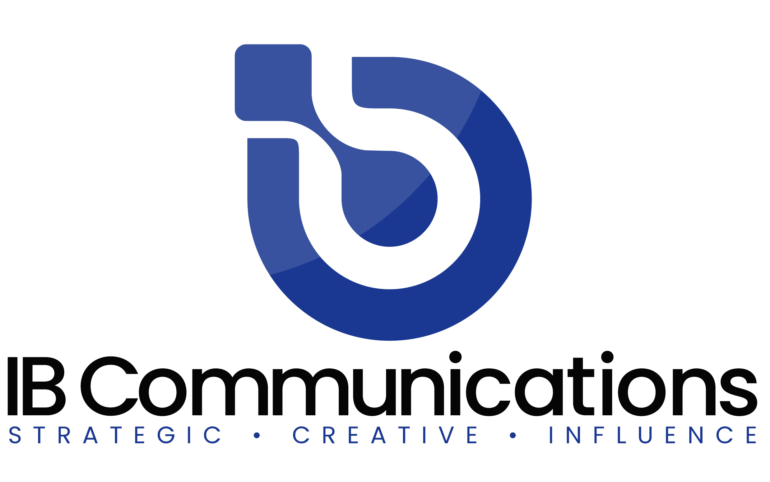
The ISCT 2023 Translational Pathway Program will feature a comprehensive lineup of plenary and concurrent sessions designed to address and overcome barriers at each stage of development across a full range of modalities such as CAR T, iPSC, and a dedicated half-day program on unlocking the potential of Exosomes (EVs). Expanding on the highly successful and unique ISCT Roundtable format, this year’s program will feature 50 Roundtable sessions providing an interactive and engaging forum for delegates to debate and move towards consensus on issues in workforce development, EU hospital exemptions, patient expanded access and process development innovation. Other Roundtable sessions will delve into capital market trends, and regional differences in CGT investment behaviour for the benefit of innovators, investigators and investors.

As a global leader in the regulatory sphere, ISCT will also host an exclusive invite-only Global Regulators Summit. This event will convene senior representatives from global regulatory agencies and government organizations to jointly address the global issue of the use of unproven cell and gene products. Discussions will inform and help pave the path forward to protect patients and the integrity of this fast-growing industry. Participants confirmed to date include key regulatory leaders and experts from ANMAT (Brazil), CAT-EMA (EU), FDA (USA), Hong Kong Department of Health, ICMR (India), MHRA (UK), NIFDC (China), PMDA (Japan), TGA (Australia).

ISCT 2023 Paris also affords participants significant networking opportunities with like-minded peers. Join the intimate Roundtable sessions, engage with authors of over 600 abstracts across 2 days of poster sessions and visit 150 exhibitors from across the globe to learn about the latest innovations and technological advancements that represent the future of cell and gene therapy.

Registration for ISCT Paris 2023 is open, and regular rates are available until May 8, 2023. For more information, please visit www.isct2023.com.

ENDS

About the International Society for Cell & Gene Therapy
Established in 1992, the International Society for Cell & Gene Therapy (ISCT) is a global society of clinicians, regulators, researchers, technologists, and industry partners with a shared vision to translate cell and gene therapy into safe and effective treatments to improve patients' lives worldwide.
ISCT is the global leader focused on pre-clinical and translational aspects of developing cell and gene-based therapeutics, thereby advancing scientific research into innovative treatments for patients. ISCT offers a unique collaborative environment that addresses three key areas of translation: Academia, Regulatory, and Commercialization. Through strong relationships with global regulatory agencies, academic institutions, and industry partners, ISCT drives the advancement of research into a standard of care.
Comprised of over 2,700 cell and gene therapy experts across five geographic regions and representation from over 60 countries, ISCT members are part of a global community of peers, thought leaders, and organizations invested in cell and gene therapy translation. For more information about the society, key initiatives, and upcoming meetings, please visit https://isctglobal.org, @ISCTglobal.

