Press Release
IB Communications
title21@ibcomms.agency

Title21 Hosts Inaugural Advisory Council Meeting to Drive Development of Interoperable CGT Software Tools
- Diverse stakeholders from across the industry gathered alongside Title21’s senior leadership to identify the greatest challenges across the CGT sector.
- The discussion highlighted a lack of interoperability causing unnecessary delays
- The complexity of collaboration, particularly between academic centers, community hospitals, and manufacturers, was discussed as another key industry challenge
- Insights from the meeting will directly impact Title21’s product development, ensuring solutions address real-world challenges.
Phoenix, AZ, September 9, 2025 – Title21 Health Solutions, the software innovators for meeting life science regulatory needs, announces the outcomes of its inaugural Advisory Council meeting, where industry leaders identified interoperability and cross-sector collaboration as two of the most pressing challenges in the CGT industry. Council members Dr. Stella Vnook, Jeff Liter, Dr. Elena Maryamchik, Robert Richards, and Caitlin Cahill met with Title21 senior leadership to assess key challenges facing the sector. Established in May, the council brings together diverse stakeholders from across the industry, each contributing unique expertise and end-user insights. This collaborative dialogue focused on identifying actionable solutions to address real-world obstacles in the field.
The conversation underscored the complexity of collaboration across academic centers, community hospitals, and manufacturers, each playing a vital role in delivering therapies to patients. However, significant data gaps between these entities pose challenges to operational efficiency. Similarly, as mobile and decentralized models are becoming more prevalent, ensuring interoperability between systems was identified as a top priority.
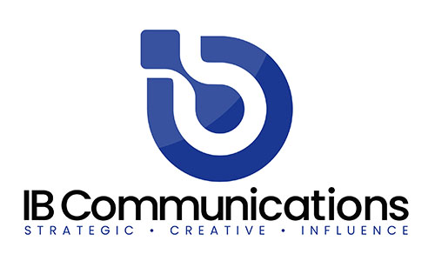
Council members also discussed the potential of data, gathered and enabled through platforms such as Title21’s software, to support predictive analytics and unlock further value. The group emphasized the importance of clearly communicating the return on investment of these capabilities to end users, including improvements in quality, cost-efficiency, and scalability.
“The inaugural Advisory Council meeting was a pivotal moment for Title21,” said Jonathan Wofford, CCO, Title21 Health Solutions. “The dialogue was rich, candid, and deeply insightful, and underscored the importance of coming together to understand the key challenges facing our industry. Without collaboration like this, we can’t advance therapies.”
Insights from the discussion will directly inform Title21’s product development priorities, solidifying the company’s long-term commitment to delivering solutions that address the evolving challenges faced by the advanced therapies sector.
The meeting took place virtually on July 16th, with the next advisory council meeting expected to take place in early 2026. Title21 plans to hold the meetings regularly to review progress, refine strategies, and stay aligned with evolving clinical and operational needs.
About Title21 Health Solutions
Title21 Health Solutions is an ArchiMed portfolio company. ArchiMed is a leading healthcare industry-focused growth equity enterprise based in New York and Lyon, France. Since 2001, Title21 Health Solutions has been dedicated to delivering easy-to-use, flexible, and integrated technology to support healthcare providers and the health sciences to achieve compliance, gain efficiencies and ensure high quality, ultimately, to support improvement in patient safety and care. The sole focus is developing technology to meet the specific needs of healthcare and life sciences firms, resulting in comprehensive solutions that are flexible to evolving business and regulatory requirements. Through the years, their partnerships with industry leaders have road-mapped their innovations to continue to meet the dynamic needs of the markets they serve. www.title21.com

