Press Release
Media Contacts:
IB Communications
reithera@ibcomms.agency

ReiThera to Attend Advanced Therapies Congress 2026 in London, Booth 295

Rome, Italy, March 4, 2026 – ReiThera, the Italian leading Contract Development and Manufacturing Organization (CDMO) specialized in the development and GMP manufacturing of viral vectors for gene therapies and vaccines, is pleased to announce its participation in Advanced Therapies UK 2026, one of the leading European events dedicated to Cell and Gene therapies and advanced biologics.

During the meeting, the company will present its poster entitled “A Novel Gorilla-Derived Oncolytic Adenovirus with Natural Selective Replication in Cancer Cells”, showcasing its proprietary GRAd-based oncolytic adenovirus platform. This technology leverages the natural tumor-selective replication properties of our gorilla-derived adenovirus backbone, while overcoming the high pre-existing seroprevalence typically associated with Ad5, offering a promising and differentiated approach in the oncolytic virotherapy landscape.

Over the years, the UK edition of this meeting has proven to be a particularly valuable platform for ReiThera — dynamic, highly international, and strongly business-oriented. The quality of discussions, the strategic mindset of attendees, and the concentration of decision-makers make it a uniquely effective environment for meaningful partnerships.

At Booth 295, the ReiThera team will be represented by:
- Claudio Panzarella, Commercial & Business Development Director
- Angelo Raggioli, PhD, Head of Technology Development
- Francesca Vidali, Marketing & Communication Specialist

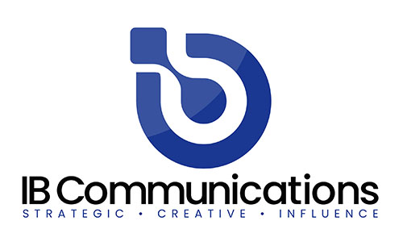
Together, the team will present ReiThera’s integrated capabilities across viral vector development and GMP manufacturing, with a strong focus on process robustness, scalability, and platform-based approaches. ReiThera is a biotechnology company specialized in the development and production of viral vectors for advanced therapies and vaccines. With established in-house manufacturing platforms, proprietary technologies, and large-scale GMP capacity, the company supports partners from early development through clinical supply, ensuring scientific rigor and industrial reliability.

Advanced Therapies UK 2026 will be an opportunity to discuss viral vector platform technologies, process development and scale-up strategies, GMP manufacturing solutions and strategic collaborations in advanced therapies.

ReiThera looks forward to connecting with partners, innovators, and industry leaders to explore how we can contribute to accelerating advanced therapy development through solid science, scalable processes, and a collaborative mindset.

Visit us at Booth 295 to discover how we work and how we can work together.

About ReiThera
ReiThera Srl is a CDMO company dedicated to technology and process development and GMP manufacturing, providing support for the clinical translation of genetic vaccines and medicinal products for advanced therapies.

The company has extensive expertise in developing scalable processes for viral-vector manufacturing and a consolidated experience in GMP production of Adeno-Associated Vector (AAV), Lentivirus, Adeno Viral vector (AdV), Modified Vaccinia Ankara and Herpes Simplex Vector.

ReiThera's core manufacturing capacity is based in a state-of-the-art facility, which includes stirred-tank bioreactors at scales of 50L, 200L, 1000L, and 2000L, as well as fixed-bed bioreactors for cell growth in adherence. The GMP facility also comprises a filling suite and quality control laboratories.

ReiThera's headquarters, R&D laboratories, and GMP facilities are located in Rome, Italy. For more information, visit www.reithera.com

