Press Release
IB Communications
title21@ibcomms.agency

Title21 Health Solutions Acquires cResults to Strengthen Quality Operations and Scheduling Capabilities in Life Sciences

Strategic acquisition extends Title21's platform into intelligent resource planning and scheduling for quality operations, furthering its life sciences mission

Phoenix, AZ, June 2 2026 - Title21 Health Solutions, a leading provider of enterprise quality and operational management platforms serving biopharma, cell and gene therapy, and the broader life sciences market, today announced its acquisition of cResults, a recognized leader in efficiency management, resource planning, and scheduling solutions for quality operations in life sciences. This acquisition enhances Title21's role as a comprehensive digital partner for regulated healthcare and life sciences organizations.

Resource planning and scheduling for quality operations have long been underserved in life sciences technology. As organizations manage more products, sites, and regulatory requirements, the lack of specialized scheduling and efficiency tools has created bottlenecks, strained resources, and delayed the delivery of critical therapies. Life sciences organizations of all sizes have long sought a unified solution that pairs quality management with intelligent resource planning and scheduling, and with the acquisition of cResults, Title21 now delivers it.

Founded in 2005, cResults brings nearly two decades of domain expertise and a proven track record with leading life sciences companies. Its flagship Smart-QX platforms deliver measurable improvements in cycle time, on-time delivery, and resource efficiency, which are increasingly important as organizations face greater regulatory scrutiny and competitive pressure.

Integrating cResults’ Smart-QX capabilities into its portfolio, which includes Quality Management Systems, cell and gene therapy orchestration platforms, and advanced analytics, further positions Title21 as a single-source provider for the full lifecycle of quality operations, from manufacturing to compliance, across cellular therapy, pharmaceutical, biotech, and life sciences sectors.

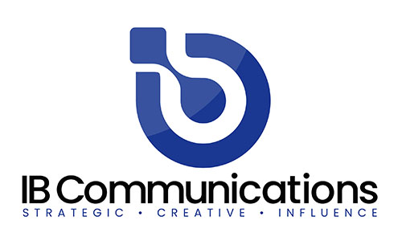
“The acquisition of cResults is a natural extension of Title21’s commitment to delivering best-in-class digital solutions for the life sciences industry,” said Tony Pare, CEO of Title21 Health Solutions. “For years, our clients have requested smarter tools for planning and scheduling their quality operations, tools that connect seamlessly with their quality management systems and give them real visibility into resource capacity and workload. The cResults portfolio fulfills this need. The Smart-QX platforms are deployed at some of the world’s leading life sciences organizations, and the ROI results in process and resource optimization are well documented. By bringing cResults into the Title21 family, we are delivering on a commitment we have made to our clients and unlocking the next generation of integrated quality operations for the industry.”

Rafi Maslaton, the Founder and President of cResults, added, “The ability to support the full supply chain required to manage and operate life sciences organizations is unmatched in our industry. Together, the combined vision of cResults and Title21 creates a major one-stop shop for digital planning, scheduling, and quality management solutions across manufacturing and quality operations. I have found the team at Title21 to be highly qualified and highly complementary to cResults. Each company brings deep expertise and best practices that will help form a world-class organization in our industry.”

This acquisition strengthens Title21’s longstanding position as an innovator in life sciences technology, building on a portfolio that helps organizations reduce operational risk, improve efficiency, and accelerate the delivery of life-saving therapies and products.

About Title21 Health Solutions
Title21 Health Solutions is an ARCHIMED portfolio company. ARCHIMED is a leading healthcare industry-focused growth equity enterprise based in New York and Lyon, France. Since 2001, Title21 Health Solutions has been dedicated to delivering easy-to-use, flexible, and integrated technology to support healthcare providers and the health sciences to achieve compliance, gain efficiencies, and ensure high quality, ultimately to support improvement in patient safety and care. The sole focus is on developing technology to meet the specific needs of healthcare and life sciences firms, resulting in comprehensive solutions that are flexible to evolving business and regulatory requirements. Through the years, their partnerships with industry leaders have road-mapped their innovations to continue to meet the dynamic needs of the markets they serve. www.title21.com

About cResults
Founded in 2005, cResults is a leading provider of SaaS-based digital performance platforms purpose-built for QC and QA laboratories. The platform delivers a unified environment for resource planning, automated scheduling, KPI monitoring, cost-of-quality analysis, and operational efficiency management within a highly configurable solution. Its Smart-FDA capability leverages AI-driven compliance intelligence and natural language processing to analyze FDA Form 483 observations, helping organizations strengthen compliance while improving operational efficiency. In addition, Smart-AID transforms the batch record review process, reducing review cycles from days to minutes. www.cresultsconsulting.com

