Press Release
IB Communications
vitalant@ibcomms.agency

Vitalant and San Diego Blood Bank Announce Strategic Merger to Enhance Community Blood Services

Scottsdale, Ariz., USA - January 8, 2025 — Vitalant and San Diego Blood Bank, two nonprofit leaders in community blood services, today announced they have entered into an agreement to merge. This strategic partnership, supported by the boards of directors for both organizations, aims to enhance services and deliver greater value to hospitals, patients and the broader community.
Uniting for a Stronger Future
By leveraging their combined expertise and resources, Vitalant and San Diego Blood Bank will offer integrated support, expanded reach, and advanced capabilities to donors, healthcare partners and patients alike.
“This partnership brings together the national reach and resources of Vitalant with San Diego Blood Bank’s deep regional expertise and trusted community relationships,” said Douglas Morton, CEO of San Diego Blood Bank. “Partnering with Vitalant now helps to further strengthen the impact of our mission. Together, we will unlock new opportunities to serve our community and enhance the resiliency of our blood supply, while continuing our unwavering commitment to donors, volunteers, hospitals, and patients.”
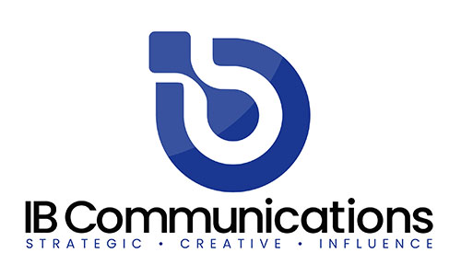
“San Diego Blood Bank has served Southern California for 75 years,” said David R. Green, CEO of Vitalant. “We look forward to building upon that legacy, offering our national resources and capabilities in transfusion medicine and biotherapies to enhance healthcare delivery. We’re grateful to both boards of directors for recognizing this opportunity to be stronger, together.”
The transaction is expected to close by mid-2026, subject to regulatory review. Upon closing, San Diego Blood Bank will become a subsidiary of Vitalant, retaining its name and Douglas Morton as CEO. A dedicated transition board of directors will also be established, ensuring a thoughtful and seamless merger that maximizes community benefit.
“We are dedicated to a smooth transition that prioritizes the needs of our community,” added Morton. “Together, we are stronger and better positioned to save and improve lives across Southern California and beyond.”
About San Diego Blood Bank
San Diego Blood Bank is a 501(c)(3) nonprofit organization also operating as Southern California Blood Bank, serving hospitals throughout Southern California. San Diego Blood Bank is dedicated to community health by providing a reliable supply of blood to patients in need. Our vision is to further ensure the health of our community by simultaneously delivering related health and wellness education and services and collaborating with various partners in medical research. For more information, visit SanDiegoBloodBank.org.
About Vitalant
Vitalant (Vye-TAL-ent) is one of the nation’s largest nonprofit blood and biotherapies healthcare organizations, providing hospitals and patients across the U.S. a safe blood supply, specialized laboratory services, transfusion medicine expertise and world-renowned research. Individuals generously donating blood, volunteering and giving financially are essential to our lifesaving mission. Learn more at vitalant.org.

