**Press Release**

**Media Contacts:**

**IB Communications**

Tel [+44 (0)20 89434685](tel:+44%20(0)20%2089434685)

[terumo@ibcomms.agency](mailto:biosenic@ibcomms.agency)

**Terumo Blood and Cell Technologies adds Mani Venkatesh to executive team as VP of Digital Transformation**

**Lakewood, Colorado, 21 May 2024 –** [Terumo Blood and Cell Technologies](https://tracking.vuelio.co.uk/tracking/click?d=ttQbtP4cf0rDiI6WHmu_Om_RuEHenuzJAegnzg_z4NnAsSwkP3zm_WcMIubTsayd0S4Nqdti76r3IWLwV4vg1gSvgBms1DRxjZuH2G7PYgqqn23zwMOot7edaZxuXLsfueKbTlWltfZ12RQLLg78G3Y1) **(Terumo BCT)**, a medical technology company, announced the promotion of Mani Venkatesh to Vice President of Digital Transformation (DX), heading the company’s new Digital Transformation Office (DX Office) and joining the Executive Management Committee. Following over two decades in the healthcare industry, Venkatesh joined Terumo BCT in 2020 as Vice President of Global Software Engineering, where he played a critical role in driving efficiencies for customers and helping lead company growth. Some notable examples of his work include the software for the Rika™ Plasma Donation System and software for the management of Terumo BCT devices used in blood centers and by cell therapy manufacturing organizations.

In the new role, Venkatesh will maximize the use of previous digital investments and oversee research and development, cybersecurity, and data privacy related to adopting emerging technologies. Previously, he held leadership positions overseeing software projects at GE Healthcare, Medtronic and Spacelabs Healthcare.

“Mani will lead the new office to empower our digital transformation by fostering a culture that embraces new technologies as a catalyst for business growth and efficiency, modernizing our foundations,” said Antoinette Gawin, President and CEO of Terum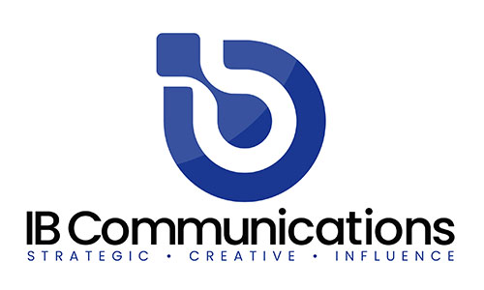o BCT.

Says Venkatesh: “It is an exciting moment as Terumo BCT moves our digital operations front and center. Every piece of our technology is supported by robust software, enabling not just operability but interoperability. By consolidating functional excellence spread throughout the company, I look forward to leveraging our collective skill sets in new ways as we advance our internal and external capabilities.”

**About Terumo Blood and Cell Technologies**

Terumo Blood and Cell Technologies (Terumo BCT) is a medical technology company. Our products, software and services enable customers to collect and prepare blood and cells to help treat challenging diseases and conditions. Our employees worldwide believe in the potential of blood and cells to do even more for patients than they do today. This belief inspires our innovation and strengthens our collaboration with customers. Terumo BCT’s customers include blood centers, hospitals, therapeutic apheresis clinics, cell collection and processing organizations, researchers and private medical practices. Our customers are based in over 150 countries. We have 750+ granted patents, with more than 150 additionally pending. We have global headquarters in Lakewood, Colorado, along with four regional headquarters, seven manufacturing sites and five research and development centers across the globe. Terumo Blood and Cell Technologies is a subsidiary of Terumo Corporation (TSE: 4543), a global leader in medical technology.