Press Release
Media Contacts:
IB Communications
team@ibcomms.agency

IBTV & IB Communications Partner with Advanced Therapies London Event to Showcase the Industry’s Innovation & News
London, UK, 13 March 2026 — IBTV, the independent broadcast platform for the biotech and advanced therapies sector and its sister company, IB Communications, are providing media services in a collaboration with Advanced Therapies London 2026, taking place in London’s ExCeL on 17–18 March 2026. IB Communications will be co-coordinating 20+ attending journalists, managing the event’s press room. While IBTV delivers video coverage and creative media production from the floor and in the media zone, capturing the conversations and innovations shaping the future of advanced therapies.
Innovation Showcase:
- CellProthera: Ibon Garitaonandria, CSO, will present on Scaling cell therapies for cardiac and neurologic diseases, whilst also moderating a Panel Discussion on
Manufacturing Strategies: Decentralised Vs. Centralised Approaches for Cell
Therapies.
- Fujifilm Biotechnologies: is presenting a session on The Future of Advanced
Therapies, a CDMO perspective.
- ScaleReady: Tony Pnewski, G-Rex Optimization Specialist, will be presenting on
Leading CGT from Good to Great Through Quality by Design (QbD).
Content Highlights:
- Opening remarks from BBC News, Tuesday 17th March: Chairs session –
Catherine Burns, BBC Health Correspondent, will kick off the Congress to start the two-day Advanced Therapies Conversations.
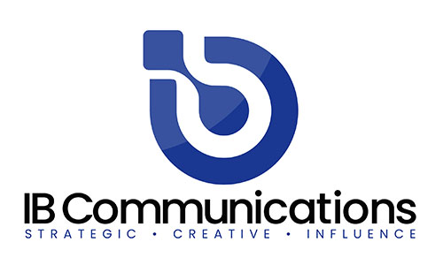
- Past, Present and Future of Gene Therapy: How far have we come?, Tuesday 17th March: Bobby Gaspar, CEO of Orchard Therapeutics, will also make his Advanced Therapies London Debut by delivering the Day 1 Opening Keynote Address. Gaspar will talk through advancements in gene and cell therapy, the journey of these life-changing modalities, and what the next decade of innovation holds for patients worldwide.
- Fireside Chat: The first successful treatment of Huntington’s disease with a gene therapy, Wednesday 18th March: Edward Wild, Professor of Neurology at The UCL Huntington’s disease centre. Wild is giving a talk on the world's first successful gene therapy for Huntington's disease, which he helped to develop.
- IBTV will begin production on series two of ‘Behind the Eight Ball’, the long-form interview series exploring defining ’failure’ moments behind life sciences leadership. The new series will start with Miguel Forte reflecting on the pivotal challenges and turning points that shaped his journey to the C-suite.
IBTV will deliver a refreshed mix of content formats, designed to inform and engage:
- ‘On the Record’ – dynamic interviews responding to industry trends, capabilities, and strategy.
- The ‘What is…’ series – clear, accessible storytelling that translates complex science.
- Roving Reporter (produced in partnership with The Medicine Maker) – 3 questions led by the Medicine Maker in interview format, conducted on the conference floor by IBTV. Published by the Medicine Maker reaching audiences beyond corporate channels.

Maintaining the independence and credibility that define IBTV, the platform will also feature an exclusive video series co‑produced by additional media partners, including Technology Networks and Drug Discovery News. This series will deliver a wide variety of bespoke editorial video formats.
[ENDS]

About IBTV

IBTV is a dedicated video and media platform for the life sciences industries, created to capture the authentic conversations and perspectives that don’t make it into press releases or polished marketing. IBTV goes beyond surface-level coverage to explore the themes shaping the future of life sciences, from emerging science to workforce challenges and patient impact.
Guided by collaboration and transparency, IBTV amplifies the voices of experts, innovators, and changemakers across the field. The mission is simple: to deliver content built by the industry, for the industry – content that informs, engages, and endures.
About IB Communications
IB Communications is the leading international life sciences communications agency in the advanced therapies space with a focus on the US and European, markets. Combining traditional PR expertise with exclusive conference partnerships, proprietary platforms, and sector‑defining initiatives, IB ensures its clients sit at the heart of the industry’s most important conversations. From best-in-class media relations and strategic storytelling to conference and event programming, IB elevates the visibility and influence of the organisations driving the future of advanced therapies.
What defines IB Communications is its creative vision, coupled with its commercially minded strategic approach that goes far beyond execution. Trusted by industry leaders, IB consistently deliver communications that create meaningful impact through strengthening reputations, shaping markets, and accelerating progress. Built on insight, partnership, and ambition, IB’s mission is simple: to use the power of communications to guide the industry toward meaningful progress and lasting impact for patients.

