Press Release
IB Communications
title21@ibcomms.agency

Title21 Health Solutions Acquires MyCellHub to Expand Digital Capabilities in Life Sciences and Advanced Therapies

Strategic acquisition accelerates Title21’s mission to deliver comprehensive, compliant, and integrated digital solutions for regulated healthcare and life sciences organizations across the cell and gene therapy ecosystem.

Phoenix, AZ, January 6 2026 - Title21 Health Solutions, a leading provider of enterprise quality management systems and cell and gene therapy orchestration platforms, announced today the acquisition of MyCellHub and its advanced manufacturing execution system (MES) platform, expanding its ability to connect the advanced therapies ecosystem through cutting-edge digital solutions.

Through the acquisition of MyCellHub, Title21 strengthens its position to serve as the data bridge connecting entities across the advanced therapies ecosystem, driving data sharing and transparency, accelerating research and therapy development, and bringing hope to patients and families through the medicine of tomorrow. Adding a MES platform to its solution portfolio, Title21 is now in a unique position to become a single-source provider for standard of care (hematopoietic cell transplant), advanced biotherapy manufacturing, integrated analytics, and quality management systems.

The MES technology is specifically designed to meet the stringent requirements of the healthcare, biotech, and cell therapy sectors by delivering real-time production monitoring, digital batch record management, and embedded quality management within manufacturing operations.

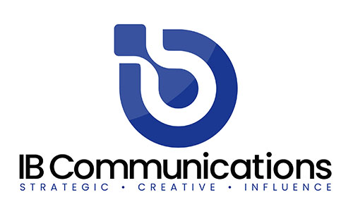
“This strategic addition to our expanding product portfolio, positions Title21 as the leader in arm-to-arm workflow, documentation, and compliance solutions for the developers, manufacturers, and clinical providers of life saving biotherapies. It also expands our geographic coverage in North America and Australia to include Europe. We welcome the Belgium based MyCellHub team to Title21 and look forward to adding them to our committed group of professionals advancing Healthcare IT in this important industry” said Tony Pare, CEO of Title21.

Jacques Parlongue , CEO of MyCellHub, stated, “We founded MyCellHub on the belief that GMP operations should be digital, efficient, and error-resistant. Title21 shares this vision. Their long history of innovation and commitment to patient safety aligns closely with our values and mission. As part of Title21, we will accelerate improvements, benefit from additional resources, and expand the tools available to support life-science organizations.”

The newly acquired MES will expand Title21’s solution portfolio, which includes Quality Management Systems (QMS), cell and gene therapy orchestration platforms, and advanced analytics offerings – all designed to meet the unique needs of providers of advanced therapy medicinal products (ATMPs).

With this acquisition, Title21 strengthens its decades-long position as an innovator in the life sciences space, providing best-in-class solutions that help organizations reduce risk, increase operational efficiency, and bring life-saving therapies to market faster.

About Title21
Title21 Health Solutions is an ArchiMed portfolio company. ArchiMed is a leading healthcare industry-focused growth equity enterprise based in New York and Lyon, France. Since 2001, Title21 Health Solutions has been dedicated to delivering easy-to-use, flexible, and integrated technology to support healthcare providers and the health sciences to achieve compliance, gain efficiencies, and ensure high quality, ultimately, to support improvement in patient safety and care. The sole focus is developing technology to meet the specific needs of healthcare and life sciences firms, resulting in comprehensive solutions that are flexible to evolving business and regulatory requirements. Through the years, their partnerships with industry leaders have road-mapped their innovations to continue to meet the dynamic needs of the markets they serve. www.title21.com

About MyCellHub
MyCellHub provides cloud-based manufacturing execution system (MES) technology tailored for regulated life science and advanced therapy manufacturing. The platform helps organizations move from paper-based processes to secure, 21 CFR Part 11–compliant digital batch records and production workflows, ensuring data integrity, process control, and regulatory compliance. MyCellHub’s solutions enable GMP teams to improve operational efficiency, enhance quality oversight, and scale complex manufacturing processes to meet changing regulatory and business needs. www.mycellhub.com

