Press Release
IB Communications
bcar@ibcomms.agency

Title21 Health Solutions Joins Blood and Cells Advocacy Roster’s (BCAR) Think-Tank Consortium

New member brings expertise in efficiencies and streamlining the role blood plays in advancing cell and gene therapies

Washington, DC and Wyoming, December 16, 2025 - Title 21 Health Solutions, the software innovators for meeting life science regulatory needs, and the Blood and Cells Advocacy Roster, (BCAR), today announce a new partnership as Title 21 joins BCAR. BCAR is an industry collaboration of leading voices working in the blood and tissue collection networks, related technology providers, biotherapy communities, and other stakeholders that communicates the importance of blood and increasing patient access to life-saving blood and advanced therapies.

“We are proud to join the Blood and Cells Advocacy Roster and contribute to its mission of communication leadership to advance patient access to life-saving blood and cellular therapies,” said Jonathan Wofford of Title21 Health Solutions. “Blood is not only foundational to healthcare, it is a critical enabler of innovation in cell and gene therapies. At Title21, we believe that by combining robust technology with the expertise of blood centers, we can help streamline processes, strengthen compliance, and ultimately improve patient outcomes.”

“We are thrilled to welcome Title21 Health Solutions to the BCAR consortium,” said Michelle Boxall, Founder of BCAR. “As innovators in regulatory and compliance software working in the blood industry, Title21 brings a vital technology perspective to our collective voice. Technology is central to solving the complex challenges facing blood and cell therapies; from ensuring quality and safety to enabling scale and access. By joining BCAR, Title21 strengthens our ability to represent the industry not only from a scientific and clinical standpoint, but also from the lens of digital innovation”.

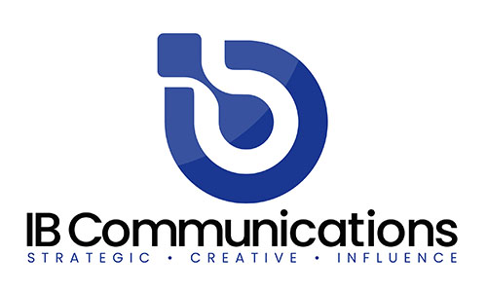
BCAR was established in 2024 as an international, collaborative body uniquely positioned to drive the narrative on the importance of the established blood industry, and in particular, its capabilities to help improve patient access to often-curative, one-dose advanced therapies. The industry has the infrastructure, experience, and know-how to quickly help bring these therapies outside of major cities and a handful of specialized hospitals.

Community blood centers supply nearly 60% of the U.S. and 25% of Canada's blood supply, with over 700 donor facilities serving more than 1,100 communities. They are uniquely positioned to play a leading role in the growth of advanced therapies. By leveraging their extensive expertise, many centers are now providing the specialized blood products necessary for cellular therapies, ensuring patients nationwide have access to groundbreaking medical innovations.

About Title21 Health Solutions
Title21 Health Solutions is an ArchiMed portfolio company. ArchiMed is a leading healthcare industry-focused growth equity enterprise based in New York and Lyon, France. Since 2001, Title21 Health Solutions has been dedicated to delivering easy-to-use, flexible, and integrated technology to support healthcare providers and the health sciences to achieve compliance, gain efficiencies and ensure high quality, ultimately, to support improvement in patient safety and care. The sole focus is developing technology to meet the specific needs of healthcare and life sciences firms, resulting in comprehensive solutions that are flexible to evolving business and regulatory requirements. Through the years, their partnerships with industry leaders have road-mapped their innovations to continue to meet the dynamic needs of the markets they serve. www.title21.com.

About Blood and Cells Advocacy Roster (BCAR)
The Blood and Cells Advocacy Roster (BCAR) is an industry collaboration between blood and tissue collection networks, related technology providers, biotherapy communities, and other stakeholders with an interest in driving the narrative on the importance of blood and increasing patient access to life-saving blood and advanced therapies. The steering committee includes members from America's Blood Centers (ABC), Association for the Advancement of Blood & Biotherapies (AABB), BioBridge Global, Blood Centers of America (BCA), Terumo Blood and Cell Technologies, Title21 Health Solutions and Vitalant.

