Press Release
IB Communications
vitalant@ibcomms.agency

Vitalant and San Diego Blood Bank Complete Strategic Merger

Combination to expand national network capabilities to Southern California, including cell and gene therapy support, cryopreservation, and therapeutic apheresis services
Scottsdale, Ariz., USA - May 5, 2026 — Vitalant, one of the nation’s largest nonprofit blood and biotherapies healthcare organizations, and San Diego Blood Bank have completed a strategic merger to enhance biotherapies services in Southern California and build a more resilient blood supply.

The merger brings together two established nonprofit blood organizations, enabling broader operational scale and access to a national infrastructure while maintaining strong local engagement in the San Diego community. The combined organization will leverage shared expertise, technology, and logistics capabilities.

“The addition of San Diego Blood Bank to Vitalant’s hub-and-spoke model¹ for expanded access to advanced therapy delivery provides a robust presence with a well-respected team in Southern California,” said Becky Cap, senior vice president of biotherapies for Vitalant. “This partnership provides the market with a set of aligned capabilities to reduce the burden of care and bring it closer to where patients live. It also represents another important step forward to help enable hospitals to open treatment opportunities for more patients to receive blood and cell-based therapeutics.”

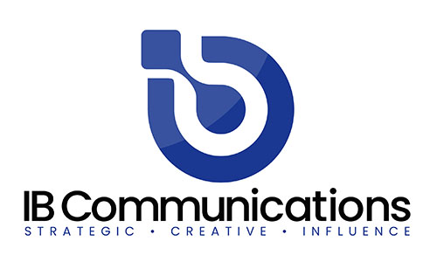
“Joining forces allows us to maintain our regional strength, which includes the trust of donors and the local community, as well as strong hospital and clinical partnerships, while expanding our impact through access to Vitalant’s broader capabilities,” said Doug Morton, CEO of San Diego Blood Bank. “Our highly engaged donor base, skilled team and regional relationships perfectly complement the enhanced operational support and expansive reach of Vitalant’s network.”

New and expanded services coming to the San Diego region will include;
- Full support for the patient journey, including coordination and logistics from the first mile of patient donation to the last mile of therapy delivery.
- Cell and gene therapy collections, such as autologous and allogeneic leukapheresis collections, and clinical trial support.
- Cryopreservation and processing services, including product preservation, processing coordination and logistics alignment for cell therapies.
- Granulocyte access and specialty products, including rare blood products, critical care support and an expanded product portfolio.
- Advanced therapeutic procedures including plasma exchange, red cell exchange, and support for hematology, neurology, and transplant pathways.

About Vitalant
Vitalant is one of the nation’s largest nonprofit blood and biotherapies healthcare organizations, providing hospitals and patients across the U.S. a safe blood supply, specialized laboratory services, transfusion medicine expertise and world-renowned research. Our biotherapies program addresses a critical gap in the rapidly evolving cell and gene therapy landscape, bridging the space between patient needs and the current capabilities of the healthcare environment. We connect hospitals, therapeutic developers and patients, enabling the delivery of care to the communities where patients live. Learn more at biotherapies.vitalanthealth.org.

About San Diego Blood Bank
San Diego Blood Bank is a 501(c)(3) nonprofit organization also operating as Southern California Blood Bank, serving hospitals throughout Southern California. San Diego Blood Bank is dedicated to community health by providing a reliable blood supply to patients in need. Our vision is to further ensure the health of our community by simultaneously delivering related health and wellness education and services and collaborating with various partners in medical research. For more information, visit sandiegobloodbank.org.

