Press Release
Media Contact:
IB Communications
title21@ibcomms.agency

Title21 to Present Poster on Efficiency Gains at Leading U.S. Cancer Center Using Digital Cell Therapy Orchestration
- Poster highlights 67% reduction in work time versus manual processes through integrated digital workflows
- Data will be presented today at Tandem Meetings 2026 in Salt Lake City, and live demos are available at booth 732

Phoenix, AZ, February 5, 2026 — Title21 Health Solutions, a leading provider of enterprise quality management systems and cell and gene therapy orchestration platforms, will present a poster today at the 2026 Tandem Meetings highlighting efficiency gains achieved by integrating its new digital cell therapy orchestration platform and advanced analytics at Memorial Sloan Kettering Cancer Center.
Developed to harmonize electronic medical record (EMR) and cellular processing laboratory systems, Title21’s platform connects clinical orders, manufacturing workflows, and quality documentation in a unified digital workflow designed for regulatory-grade traceability. In early outcomes, the integrated approach reduced staff work time by 67% compared with prior manual processes, while helping reduce transcription steps and improve data consistency across teams involved in cellular therapy delivery.
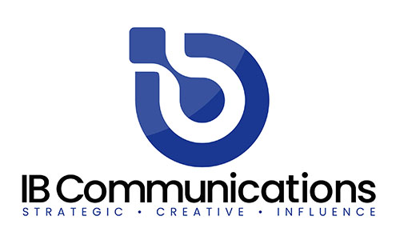
- Poster Session: Integrating Digital Systems to Advance Automation, Accuracy, and Regulatory Alignment in Cellular Therapy: Early Outcomes from Implementation at Memorial Sloan Kettering Cancer Center
- Time: February 5, 2026 from 6:30 – 8:30pm
- Poster Number: 29274
“Digital orchestration is no longer a ‘nice to have’ for cellular therapy programs. It is a practical path to reducing operational burden while strengthening end-to-end compliance and audit readiness,” said Jonathan Wofford, CCO, Title21.
Title21 will offer live demos at booth 732. To schedule a meeting, visit https://title21.com/tandem26.
About Title21 Health Solutions
Title21 Health Solutions is an ArchiMed portfolio company. ArchiMed is a leading healthcare industry-focused growth equity enterprise based in New York and Lyon, France. Since 2001, Title21 Health Solutions has been dedicated to delivering easy-to-use, flexible, and integrated technology to support healthcare providers and the health sciences to achieve compliance, gain efficiencies and ensure high quality, ultimately, to support improvement in patient safety and care. The sole focus is developing technology to meet the specific needs of healthcare and life sciences firms, resulting in comprehensive solutions that are flexible to evolving business and regulatory requirements. Through the years, their partnerships with industry leaders have road-mapped their innovations to continue to meet the dynamic needs of the markets they serve. www.title21.com

