**Press Release**

**Media Contacts:**

**IB Communications**

Tel [+44 (0)20 89434685](tel:+44%20(0)20%2089434685)

[team@ibcomms.agency](mailto:team@ibcomms.agency)

**IB Communications Partners with Terrapinn for Advanced Therapies Congress in London**

**IBTV rolls out new collaboration with The Medicine Maker to provide video panel discussions and ‘Roving Reporter’ interviews from the Advanced Therapies Congress show floor.**

**London, UK; March 14, 2025** - [IB Communications](https://tracking.vuelio.co.uk/tracking/click?d=W-6cWkYntmIdX98oThaCixdF7hH0Noq1bfz-r_LPjFDJzIzBEAYcIEIgGJHNY0LLV4tfd0MA8kQKE3sWCgwFJALDxTFsJi5PLAoAgHYJi2-TCr0kleKm_RmRR-AjeHLIQojlPTGpYLYfXIalualzuxI1), an international media relations and public strategy firm, and Terrapinn, a global company whose events promote innovation and technology that changes people’s lives, today announce a partnership to increase audience reach of the life sciences community for the content for Advanced Therapies UK 2025, the annual cell and gene therapy congress held at ExCel London next week, from 18-19 March. The congress will include a conference with over 2,500 attendees and 300 speakers, as well as over 100 exhibitors and 12+ hours of dedicated networking time.

The advanced therapies field is still young but nearing a critical juncture, as a robust pipeline of remarkable therapies for once-intractable diseases march through clinical trials and onto the market. Still, patient access is the name of the game, and while strides are being made across the industry, some investors are showing less patience. As such, half of the conference’s 10 tracks will focus on pieces of the cost puzzle, including supply chain and logistics, vector and therapy manufacturing, innovation and pricing.

IB Communications has already registered 12 journalists covering news announcements from the event, content from the sessions, and interviewing attending leaders of industry.

IBTV, the video partner of IB Communications, will be producing Spotlight panel interviews observing key trends in the industry, posing questions around CGT for non-oncological indications, and whether there’s such a thing as GMP starting materials. IBTV will also be capturing ‘Movers & Shak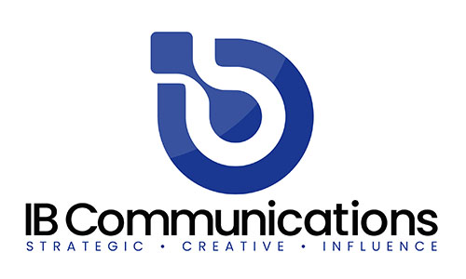ers’ interviews with KOLs on the show floor, as well as rolling out a new collaboration with The Medicine Maker to provide ‘Roving Reporter’ video content.

The Medicine Maker and IBTV are also on the conference agenda with ‘View from the C-Suite’; a session taking place from 16:10-16:50 on Tuesday 18 March 2025 in Track 8. The session will be hosted by The Medicine Maker’s Rich Whitworth and IBTV’s Georgi Makin. Leaders of industry, Miguel Forte (CEO, Kiji Therapeutics), Sven Kili (Partner, Saisei Ventures) and Angela Osborne (CEO, eXmoor Pharma) will be chewing over the big trends, challenges, and opportunities after a stormy start to 2025.

The conference begins at 9:00 on Tuesday 18 March, and Advanced Therapies Congress Chair, Miguel Forte, will lead a keynote panel on the state of the industry at 9:30. The panel features industry, academic and investor leaders including:

* Eric David, BridgeBio Gene Therapy
* Lara Campana, Resolution Therapeutics
* Jordan Schecter, Johnson & Johnson
* Dame Molly Morag Stevens, University of Oxford
* Matthieu Coutet, Sofinnova Partners

Key highlights from the agenda include:

* Catalent’s Rupa Pike’s presentation, ‘Data-Driven Manufacturing: A Formula for Success in Cell Therapy’.
* ReiThera is unveiling its ReiCell-AAV platform for High-Efficiency Gene Therapy AAV Production, adding to its MVA and GRAd vector capabilities
* CellProthera’s Ibon Garitaonandia, CSO, will be taking part in the opening panel discussion, 'Allogeneic vs. Autologous Approaches’. Ibon will also share insight into the development of CellProthera’s ProtheraCytes during his presentation, ‘Development of cell-based therapies for Post-acute Myocardial Infarction’.
* Anthony Nolan will lead a roundtable exploring the navigation of regulatory compliance in the sourcing and supply of cellular starting materials for cell therapy, and asking ‘can cellular starting materials be ‘GMP’?