Press Release
Media Contacts:
IB Communications
team@ibcomms.agency

IBTV and AABB Partner to Spotlight the Future of Blood and Biotherapies at 2025 Annual Meeting
Wyoming, US, 24 Oct 2025 — IBTV, the independent broadcast division of IB Communications, is proud to announce its partnership with AABB to deliver video coverage and creative media production at the 2025 AABB Annual Meeting. This collaboration will bring the meeting’s most compelling conversations and innovations to life - capturing not just what happens on stage, but the ideas that ripple far beyond it.
From the general session featuring Tom Whitehead of the Emily Whitehead Foundation - whose family’s journey was an integral part of advancing the CAR-T revolution - to dynamic panel discussions on custom-fit care and data-driven therapy delivery, IBTV will be on the ground to document the voices shaping the future of blood and biotherapies.
Content Highlights
- Making It Work: Real Examples of Custom-Fit Care in Biotherapy Monday, 27 Oct – 9:30am, Biotherapies Pavilion Hosted by Kate Fry (America’s Blood Centers), this panel brings together Becky Cap (Vitalant), Scott Grady (Versiti), Trevor Smith (Terumo BCT), and Heather Munoz (BioBridge Global) to explore how organizations are creatively adapting biotherapy delivery to meet diverse patient needs. Expect real-world case studies, operational ingenuity, and candid insights into what “making it work” really looks like.
- Leveraging Data Sharing to Enhance Patient Access and Therapy Delivery Sunday, 26 Oct – Roundtable Discussion A timely conversation on the infrastructure behind innovation. Chetan Makam (Terumo BCT), Becky Cap (Vitalant), Jonathan Wofford (Title 21), and Jeff Wren (AABB) will unpack how data collaboration is unlocking new efficiencies in clinical workflows and expanding access to advanced therapies.
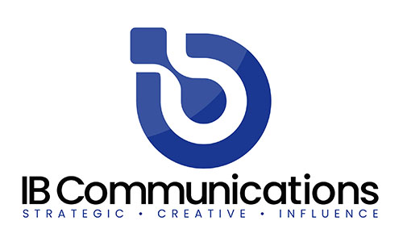
- Beyond the Dish: Unlocking the Potential of Organoids Monday, 27th Oct – 2.30pm, Biotherapies Pavillion. With speakers from Pluristyx and BioLife Solutions, this session dives into the frontier of organoid science, where miniature, lab-grown tissues are reshaping drug development, disease modeling, and regenerative medicine. A must-watch for anyone tracking the next wave of cellular innovation.
New Formats to Amplify the Conversation
IBTV will debut several refreshed content formats designed to inform and inspire:
- ‘On the Record’ – Short-form interviews with influential voices and emerging thinkers.
- ‘Roving Reporter’ – Real-time perspectives from the show floor, produced with The Medicine Maker.
- ‘In Conversation With…’ – Intimate interviews that go beyond the headlines.
- ‘360’ Panel Discussions – Editorially driven roundtables offering depth, nuance, and debate.
Each format is crafted to provide media outlets with rich storytelling angles and shareable assets, while giving industry leaders a platform to speak directly to peers, partners, and the public.
More Than Coverage - A Continuation of the Conversation
IBTV’s work doesn’t end when the meeting does. Through ongoing collaborations with global life sciences events, the team helps ensure that the ideas sparked in conference halls has follow through. With a blend of journalistic integrity and creative production, IBTV is turning moments into movements.
For media or event partners interested in video collaborations, or to discuss potential coverage opportunities at the AABB Annual Meeting, please contact Michelle Boxall, CEO of IB Communications, or speak with the AABB events team.
About IBTV
IBTV is a dedicated video and media platform for the life sciences industries, created to
capture the authentic conversations and perspectives that don’t make it into press
releases or polished marketing. We go beyond surface-level coverage to explore the
themes shaping the future of life sciences, from emerging science to workforce challenges and patient impact.

Guided by collaboration and transparency, IBTV amplifies the voices of experts, innovators, and changemakers across the field. Our mission is simple: to deliver content built by the industry, for the industry – content that informs, engages, and endures.

