Press Release
Media Contacts:
IB Communications
exmoor@ibcomms.agency

eXmoor Pharma and Anthony Nolan Cell Therapy and Laboratory Services to offer end-to-end support for cell therapy developers
Bristol and London, UK, 2nd September 2025 - eXmoor Pharma, the integrated cell and gene therapy CDMO with embedded consultancy expertise, has announced a new strategic partnership with Anthony Nolan: Cell Therapy & Laboratory Services (CT&LS), the experts in cellular starting materials providing donor material solutions to the cell and gene therapy industry.
This collaboration brings together two UK-based advanced therapy organisations with highly complementary capabilities. It offers a fully joined-up, ethically and scalable driven solution for developers of autologous and allogeneic cell therapies.
Together, eXmoor and Anthony Nolan’s CT&LS will provide an end-to-end service that spans donor sourcing and screening, apheresis collection, process development and GMP manufacturing. The partnership supports clients to move from starting material to clinical supply with confidence, compliance and a shared focus on both patient and donor welfare.
Complementary capabilities across the full cell therapy journey
As part of the partnership:
- Anthony Nolan’s CT&LS will provide starting material using their cell collection capabilities: a donor register with over 900,000 HLA-typed searchable donors, donor matching and bioinformatics expertise, a cord blood collection programme and a newly opened apheresis collection centre in Nottingham. They bring 50+ years of experience of working with and looking after donors, with standards of donor care in place to make provision reliable and scalable from research to GMP manufacturing.
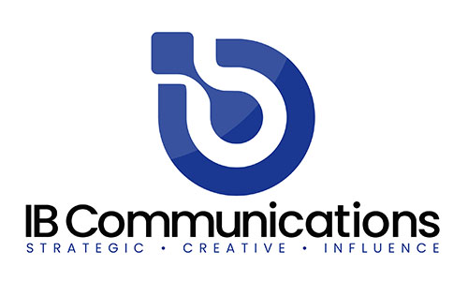
- eXmoor Pharma will receive and process this material at its clinical GMP facility in Bristol. The site provides integrated process development, fill-finish and manufacturing services for both autologous and allogeneic therapies. eXmoor has passed Anthony Nolan CT&LS’s ethical review board, ensuring shared ethical and operational standards across the collaboration.
Shared commitment to ethical and efficient delivery
Lucy Foley, CEO of eXmoor Pharma, commented:
“We are proud to partner with Anthony Nolan’s CT&LS, powered by a UK institution with unmatched expertise in donor services and ethical sourcing. Together, we can offer cell therapy developers a truly integrated path from donor to patient. This partnership reinforces our commitment not only to technical excellence but also to ethical responsibility, keeping both donors and patients at the centre of everything we do.”
David Bennett, Director of Business Development for Anthony Nolan’s Cell Therapy and Lab Services, said:
“As the cell and gene therapy industry evolves, collaboration becomes more important. Our 50+ years of experience in working with donors and our large and diverse register, make Anthony Nolan’s CT&LS the obvious choice for partners like eXmoor who are looking to accelerate therapy development. I’m hugely excited for this new partnership to provide a seamless service for cell and gene therapy developers, facilitating innovation by leveraging our combined expertise in sourcing material and manufacturing.”
By working closely from the earliest stages, eXmoor and Anthony Nolan’s CT&LS aim to streamline delivery timelines, reduce complexity, and ensure that cell therapies are developed and delivered with the highest clinical and ethical standards.
About eXmoor Pharma
eXmoor Pharma is a cell and gene therapy specialist CDMO with embedded consultancy expertise. Founded in 2004, eXmoor supports clients across Viral Vectors, Autologous and Allogeneic Cell Therapies, and RNA technologies. It guides projects from early CMC strategy to GMP manufacture with regulatory insight, IP freedom and a collaborative model that accelerates success.

About Anthony Nolan’s Cell Therapy and Lab Services
Anthony Nolan has been at the forefront of clinical cell therapy for over 50 years. Our Cell Therapy and Laboratory Services make use of this expertise in cell collection, donor recruitment, tissue typing, and clinical-grade biobanking. The organisation has established a robust infrastructure for ethically sourcing, processing, and supplying high-quality starting material for therapeutic and research purposes.

