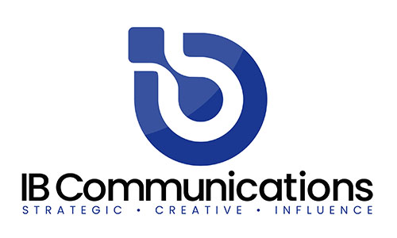

Press Release
Media Contacts:
IB Communications
Tel +44 (0)20 89434685
immutep@ibcomms.agency

Immutep announces promising initial clinical data from INSIGHT-003 at SITC 2022

- First activity evaluation of efti as part of triple combination therapy yields promising early results with 72.7 percent response rate and 90.9 percent disease control rate in first-line NSCLC patients
- The triple combination therapy has been well tolerated and appears to be safe

Sydney, Australia, November 10, 2022 – Immutep Limited (ASX: IMM; NASDAQ: IMMP) ("Immutep” or “the Company”), a clinical-stage biotechnology company developing novel LAG-3 immunotherapies for cancer and autoimmune disease, today announces encouraging initial clinical data from the investigator-initiated INSIGHT-003 trial has been published in a poster presentation at the Society for Immunotherapy of Cancer (SITC) Annual Meeting 2022. INSIGHT-003 is the first trial evaluating Immutep’s lead product candidate, eftilagimod alpha (“efti” or “IMP321”) as part of a triple combination therapy with standard-of-care anti-PD-1 therapy and chemotherapy.

The poster entitled “Feasibility of eftilagimod alpha (soluble LAG-3 protein) combined with standard-of-care therapy in advanced non-small-cell lung cancer (NSCLC). Initial results from INSIGHT 003” provided initial efficacy details on 11 of 14 patients currently treated with subcutaneous efti in combination with pembrolizumab and doublet chemotherapy (carboplatin and pemetrexed) delivered intravenously in first-line NSCLC patients. Safety-related information was provided for the 14 patients currently enrolled in the trial.

The initial clinical data show that the approach is well-tolerated and provides promising early signals of therapeutic activity with an Objective Response Rate (ORR) of 72.7 percent (8/11) and a Disease Control Rate (DCR) of 90.9 percent (10/11).

Notably, 81.8 percent (9/11) of patients had a PD-L1 Tumour Proportion Score (TPS) of less than 50 percent. This is generally consistent with the overall patient population in this indication where roughly 70 percent of patients have a PD-L1 expression level below 50 percent. These patients are usually less responsive to anti-PD-1-based therapy compared with patients having a TPS of greater than or equal to 50 percent, necessitating new approaches to fight their cancers. For the 9 patients in the INSIGHT-003 trial having PD-L1 TPS of less than 50 percent, the ORR was also a promising 66.7 percent (6/9) and DCR was 88.9 percent (8/9).

Prof. Dr. Salah-Eddin Al-Batran, Scientific Lead of the INSIGHT study, noted: “Efti has accumulated an excellent safety profile to date, driving its high suitability for combination with standard-of-care therapies to address areas of unmet need for cancer patients. INSIGHT-003 represents the first triple combination therapy consisting of efti plus anti-PD-1 and chemo, and we are pleased with these promising, early results.”

Immutep’s CEO Marc Voigt also added: “We are encouraged to see these promising initial results from INSIGHT-003. When taken in conjunction with the data reported from our other trials, they give us continued confidence in the flexibility of efti to be safely combined in various novel formats and enhance various therapeutic approaches for multiple solid tumours. Importantly, INSIGHT-003 may also help to further inform the late-stage trial design options for efti, our first-in-class soluble LAG-3 protein, in first-line non-small cell lung cancer.”

Immutep’s CSO & CMO Dr Frederic Triebel, also noted: “This early data represents a strong start. We have previously seen efti enhance anti-PD-(L)1 therapy and chemotherapy, separately, and so the combination of all three therapies in INSIGHT-003 is instructive. In particular, this data continues to build our understanding of efti’s ability to boost the innate and adaptive immune system and provides important insights into how efti may ultimately meet diverse NSCLC patient needs in both chemo and chemo-free settings. We look forward to seeing the data mature.”

Initial Efficacy Results Summary
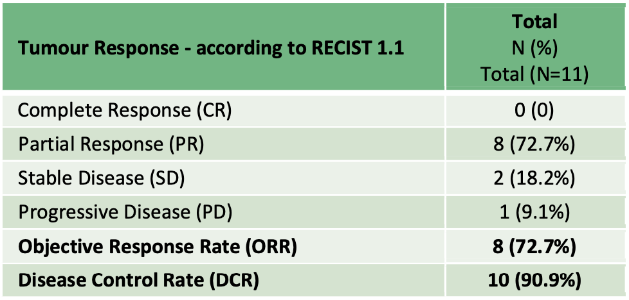
Table 1: ORR and DCR for INSIGHT-003 (data cut-off date: 14 October 2022)

Safety
The combination therapy has been well tolerated and appears to be safe, with only 1 immune-related SAE (pancreatitis) relating to the study treatment (i.e. pembro/efti).

Conclusion
The triple combination therapy of efti in combination with anti-PD-1 therapy and chemotherapy appears to be feasible and safe. Furthermore, first promising signals of therapeutic activity were detected and will continue to be evaluated as the trial progresses.

Separately, this Trial in Progress poster presentation of the TACTI-003 randomized Phase IIb study of eftilagimod alpha and pembrolizumab as first-line treatment of patients with recurrent or metastatic head and neck squamous cell carcinoma was also presented at SITC.

ENDS

About Eftilagimod Alpha (Efti)
Efti is Immutep’s proprietary soluble LAG-3 clinical stage candidate that is a first-in-class antigen presenting cell (APC) activator for the treatment of cancer, capitalising on LAG-3’s unique characteristics to stimulate both innate and adaptive immunity. Efti binds to and activates antigen presenting cells via MHC II molecules leading to expansion and proliferation of CD8+ (cytotoxic) T cells, CD4+ (helper) T cells, dendritic cells, NK cells, and monocytes. It also upregulates the expression of key biological molecules like CXCL10 that further boost the immune system’s ability to fight cancer.
Efti is under evaluation for a variety of solid tumours including non-small cell lung cancer (NSCLC), head and neck squamous cell carcinoma (HNSCC), and HER2–/HR+ metastatic breast cancer. Its favourable safety profile enables various combinations, including with anti-PD-[L]1 immunotherapy and/or chemotherapy. Efti has received Fast Track Designation in first-line HNSCC and in first-line NSCLC from the United States Food and Drug Administration (FDA).

About INSIGHT-003
INSIGHT-003 is an investigator-initiated study conducted by the Institute of Clinical Cancer Research IKF at Krankenhaus Nordwest in Frankfurt. It is being run as the third arm (Stratum C) of the ongoing Phase I INSIGHT trial with Prof. Dr. Salah-Eddin Al-Batran as lead investigator. The study is evaluating a triple combination therapy consisting of efti in conjunction with an existing approved standard-of-care combination of anti-PD1 therapy and chemotherapy. Up to 20 patients with solid tumours will be recruited to participate in the trial. Patients will receive 30 mg subcutaneous doses of efti every two weeks in conjunction with standard-of-care anti-PD-1 therapy plus chemotherapy. The trial will assess the safety, tolerability, and initial efficacy of the combination.

About Immutep
Immutep is a clinical stage biotechnology company leading the development of LAG-3 related immunotherapy products for the treatment of cancer and autoimmune disease. The Company is dedicated to leveraging its technology and expertise to bring innovative treatment options to market for patients and to maximise value to shareholders. Immutep’s lead product candidate is eftilagimod alpha (“efti” or “IMP321”), a soluble LAG-3 fusion protein (LAG-3Ig), which is a first-in-class antigen presenting cell (APC) activator being explored in cancer in multiple clinical trials. The Company is also developing an agonist of LAG-3 (IMP761) for autoimmune disease. Additional LAG-3 product candidates, including antibodies for immune response modulation, are licensed to and being developed by Immutep’s large pharmaceutical partners. Further information can be found on the Company’s website www.immutep.com.

