**Press Release**

**IB Communications**

Tel +44 (0)20 89434685

[terumo@ibcomms.agency](mailto:terumo@ibcomms.agency)

**Terumo Blood and Cell Technologies Names Patrick Daly as Chief Business Officer**

**Daly, a 30-year veteran of the healthcare industry, is the latest leadership addition to help Terumo BCT unite business areas and fuel enterprise growth**

**LAKEWOOD, Colorado, — April 16, 2025 —** [Terumo Blood and Cell Technologies](https://tracking.vuelio.co.uk/tracking/click?d=capLFI4mcp1Ex8830pa4oTpcQ083U5T80WMWkyhkR56K7ZF28SfJk5zJLw9Jh-okgKDMcKWXDZpv2TnQdxXMj-OigY6lPPhB-R1acF1B9k2t5tAh-vI5LJRGmcMXCK5-Tg2) **(Terumo BCT)**, a medical technology company, today announced the addition of Patrick Daly as its Chief Business Officer as the company continues to expand its capabilities to meet evolving market segments. Daly joins Terumo BCT with over 30 years of business and healthcare industry experience, both domestically and internationally. Most recently, he built the MedTech Global Data franchise at IQVIA, a provider of technology solutions to the life sciences industry.

Daly has spent his career building commercial capabilities to deliver organic and inorganic growth. Before joining IQVIA, he was President and CEO of Cohera Medical, and he remains an independent Board Director for BioStem Technologies. He has held successive senior leadership roles in strategic marketing, sales and business development across various regions and businesses of Johnson & Johnson. He earned his Bachelor of Science in Foreign Area Studies from the U.S. Military Academy at West Point.

"Patrick's experience acquiring capital and building strategic partnerships complements his experience monetizing data and solutions. This uniquely positions him to integrate our offerings and drive innovation across our business models and go-to-market strategies,” said Antoinette Gawin, President and Chief Executive Officer of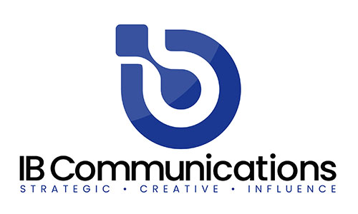 Terumo BCT. “His diverse experience will help accelerate our ambitions for double-digit growth."

“It is a great moment to join Terumo BCT as it continues executing its long-term vision for growth and to meet patients’ unmet needs globally,” said Daly. “I am focused on ensuring our full portfolio, connected with data, software and services, will play a growing role in helping our customers solve healthcare's toughest challenges, while advancing disease research, therapeutic development and improved access to safe blood worldwide.”

**About Terumo Blood and Cell Technologies**

Terumo Blood and Cell Technologies is a medical technology company. Our products, software and services enable customers to collect and prepare blood and cells to help treat challenging diseases and conditions. Our employees worldwide believe in the potential of blood and cells to do even more for patients than they do today. This belief inspires our innovation and strengthens our collaboration with customers.

Terumo Blood and Cell Technologies' customers include blood centers, hospitals, therapeutic apheresis clinics, cell collection and processing organizations, researchers and private medical practices. Our customers are based in over 150 countries across the globe. We have 750+ granted patents, with more than 150 additionally pending.

We have global headquarters in Lakewood, Colorado, U.S.A., along with five regional headquarters, eight manufacturing sites and six innovation and development centers across the globe. Terumo Blood and Cell Technologies is a subsidiary of Terumo Corporation (TSE: 4543), a global leader in medical technology.