Press Release
Media Contact:
IB Communcations
organabio@ibcomms.agency

OrganaBio Expands Rapid PBMC Processing to San Diego at Excellos Labs

OrganaBio launches time-sensitive PBMC isolation in San Diego, extending rapid clinical sample processing to one of the largest cell and gene therapy hubs in the country

San Diego, CA, June 25, 2026 — OrganaBio, LLC ("OrganaBio"), a manufacturer of Research- and cGMP-grade cells and blood-derived products and provider of cell isolation and cryopreservation services, today announced the opening of a new PBMC processing and cryopreservation laboratory at Excellos Labs in San Diego, further strengthening its nationwide network supporting cell therapy developers and clinical trial sponsors. The new laboratory marks the first expansion of services through Excellos Labs since OrganaBio’s May 2026 acquisition.

The launch expands time-sensitive PBMC isolation in the heart of one of the most concentrated advanced therapy ecosystems in the world. Positioned near the region’s leading research institutions, clinical research centers, and cell and gene therapy developers, the laboratory enables faster, more efficient support for Southern California clinical sites that require rapid processing of clinical trial samples

With this expansion, sponsors can have cryopreserved samples within three to four hours of collection, a critical factor for maintaining cell viability and function. OrganaBio offers industry-leading turnaround times and exceptional quality metrics, with an average PBMC viability of 99.1% and PBMC recovery exceeding 2.9 x 106 /mL. That performance is driven by a rigorously trained team qualified across multiple internal and sponsor-specific SOPs.

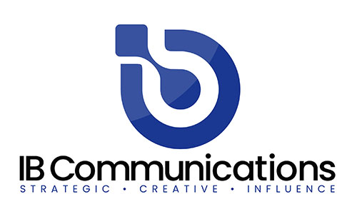
OrganaBio’s operators routinely isolate PBMCs from leukopaks and whole blood in support of the company’s cellular starting material business, and they travel between sites to ensure consistency, reproducibility, and quality across the network. With the addition of Excellos Labs’ San Diego footprint, OrganaBio now operates three West Coast laboratories alongside its Miami headquarters, giving sponsors coast-to-coast coverage as their clinical programs scale and expand geographically.

“Standing up rapid PBMC processing at Excellos Labs means that sponsors running trials across Southern California can now access the same high-viability sample processing our partners rely on coast to coast, with no tradeoff between speed and quality,” said Justin Irizarry, CEO of OrganaBio. “This is only the first example of the many cross-organizational benefits we can leverage to enhance our partners’ experience, as we continue to merge operations between OrganaBio and Excellos Labs.”

With operations now spanning Miami, Irvine, the San Francisco Bay Area and San Diego, OrganaBio continues to build on its mission to accelerate access to high-quality donor materials and manufacturing solutions, supporting the rapid development and delivery of next-generation therapies.

About OrganaBio
OrganaBio, LLC is a vertically integrated cell therapy contract development and manufacturing organization (CTDMO) headquartered in Miami, Florida, with cGMP manufacturing and cell processing facilities in Miami and San Diego and regional cell processing labs in San Francisco and Irvine. Through its wholly owned, FDA-registered subsidiaries – HemaCenter, LLC (adult leukapheresis) and GaiaGift, LLC (birth tissue and cord blood) – OrganaBio operates proprietary supply chains for ethically sourced human tissues and blood-derived cellular products. The combined platform delivers GMP isolated cells, clinical-sample processing including PBMC isolation, cell isolation and cryopreservation services, cGMP manufacturing for autologous and allogeneic cell therapies, process development, analytical testing, quality assurance, and regulatory support under a single quality framework, enabling cell therapy developers to accelerate the path from development to patient. For more information, visit www.organabio.com.

About Excellos
Excellos Labs, LLC is the San Diego operation of OrganaBio, LLC, formed when OrganaBio acquired the operating assets of Excellos, Inc. in May 2026. Founded in 2021 as an independent spinout of the San Diego Blood Bank, Excellos built a purpose-built, full-service cell therapy facility in downtown San Diego featuring five ISO 7 cGMP cleanroom suites. The site supports autologous and allogeneic cell therapy manufacturing, apheresis donor cell collection, cell isolation and enrichment, transduction, expansion, fill/finish, and cryopreservation. The core Excellos team was retained through the transaction, and existing customer programs continue under Excellos Labs as part of OrganaBio’s bicoastal platform, operating under a single quality system across all sites. For more information, visit www.excelloslabs.com

