Press Release
Media Contacts:
IB Communications
terumo@ibcomms.agency

Terumo Blood and Cell Technologies Appoints Liza Loidolt as General Manager of Cell and Gene Therapy Business
- New leadership role sharpens company’s focus on accelerating innovation and access in the cell and gene therapy market.
LAKEWOOD, Colo., USA - November 13, 2025 – Terumo Blood and Cell Technologies (Terumo BCT) a medical technology company, today announced the appointment of Liza Loidolt as General Manager of the company’s Cell and Gene Therapy (CGT) business. This leadership appointment strengthens Terumo BCT’s commitment to advancing innovation and expanding access to life-changing cell and gene therapies worldwide.
With more than 15 years of experience in biotechnology and pharmaceuticals, Loidolt brings a proven record of global commercial leadership across hematology and cell therapy. She has held senior roles in large pharma and biotech organizations, including Novartis, where she contributed to the launch of Kymriah —the first FDA-approved CAR-T therapy — and Kite Pharma, where she led commercialization efforts for Yescarta and Tecartus across the U.S. and U.K.
Loidolt will lead the integration of commercial, marketing and scientific engagement across diverse global regions, driving focus, strategic alignment and operational excellence. She reports to Veerle D’Haenens, General Manager of the company’s Global Therapy Innovations business unit, which brings together Therapeutic Apheresis and Cell and Gene Therapy under one global cohesive organization, delivering advanced, connected technologies that enable therapy journeys from cell collection to patient treatment.
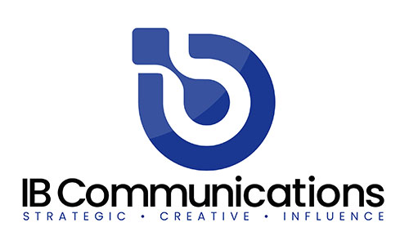
“Unifying our CGT teams under one leadership structure helps us move with greater speed and focus,” said Veerle D’Haenens. “By aligning innovation with cross-functional expertise, we can deliver streamlined, end-to-end technical solutions that help healthcare providers and therapy developers overcome complexity, scale faster and bring advanced treatments to patients who need them.”
“Terumo Blood and Cell Technologies has a unique opportunity to shape the future of cell and gene therapy, a field evolving at unprecedented speed,” said Loidolt. “Our focus is on making it easier for innovators to move from concept to clinic. By connecting the full therapy continuum — from cell collection through downstream processing — we’re helping customers shorten development timelines, improve consistency and reduce cost. These are the real levers that increase access for patients.”
Under Loidolt’s leadership, the CGT business aims to expand Terumo BCT’s global footprint in cell processing and services, deepen strategic partnerships and continue delivering fit-for-purpose, customer-centric solutions that meet evolving industry needs — from closed-system automation and data-driven process control to scalable manufacturing platforms that grow with customer demand.
Terumo BCT’s platforms, the Spectra Optia™ Apheresis System, Quantum Flex™ Cell Expansion System, and Finia™ Fill and Finish System, form a connected end-to-end system that helps therapy developers streamline operations and accelerate commercialization.
Loidolt added, “Success in cell and gene therapy requires us to think boldly, take smart risks and remain deeply responsive to customer needs, all while staying true to our core values of respect, integrity, quality and care. My priority is driving impactful solutions that meet today’s needs and can scale for the future.”
Spectra Optia™, Quantum Flex™ and Finia™ are either registered trademarks or trademarks of Terumo BCT, Inc. in the United States and/or other countries. See TerumoBCT.com/trademarks for details.
About Terumo BCT
Terumo Blood and Cell Technologies is a medical technology company. Our products, software and services enable customers to collect and prepare blood and cells to help treat challenging diseases and conditions. Our employees worldwide believe in the potential of blood and cells to do even more for patients than they do today. This belief inspires our innovation and strengthens our collaboration with customers.
Terumo Blood and Cell Technologies' customers include blood centers, hospitals, therapeutic apheresis clinics, cell collection and processing organizations, researchers and private medical practices. Our customers are based in over 160 countries across the globe. We have 750+ granted patents, with more than 150 additionally pending.
We have global headquarters in Lakewood, Colorado, U.S.A., along with four regional headquarters, eight manufacturing sites and six innovation and development centers across the globe. Terumo Blood and Cell Technologies is a subsidiary of Terumo Corporation (TSE: 4543), a global leader in medical technology.

