Press Release
Media Contacts:
IB Communications
exmoor@ibcomms.agency

eXmoor Pharma appoints Manuel Balbuena as Chief Commercial Officer to strengthen global commercial strategy

Bristol, UK – 3 March 2026 - eXmoor Pharma has appointed Manuel Balbuena as Chief Commercial Officer as the company continues to build its position as a leading integrated cell and gene therapy CDMO, partnering with clients across complex and emerging modalities.

Manuel brings more than 15 years of commercial leadership experience in the life sciences sector, including seven years in the cell and gene therapy and biologics CDMO industry. He joins eXmoor Pharma from AGC Biologics, where he held senior commercial roles across Europe and built a strong track record in global business development, strategic account growth and international market expansion.

His appointment reflects eXmoor’s continued evolution as an integrated consultancy and GMP manufacturing partner supporting innovators across viral vectors, cell therapies and RNA technologies. As Chief Commercial Officer, Manuel will lead the company’s global commercial strategy, strengthen existing client relationships, build new strategic partnerships and support the company’s expansion across Europe, the US and other international markets.

Lucy Foley, CEO of eXmoor Pharma, commented:
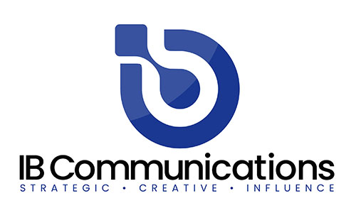
“Manuel joins eXmoor at an important stage in our development. His deep experience within the cell and gene therapy and biologics CDMO sector strengthens our ability to partner with global clients across a range of complex modalities. We are focused on building long-term strategic relationships and delivering commercial and operational excellence, and Manuel’s leadership will be central to that ambition.”

Manuel Balbuena added:
“Having worked across global CDMO organisations, I recognise the importance of aligning technical depth with commercial clarity. eXmoor’s integrated model creates a strong platform for sustainable growth. I look forward to strengthening our partnerships with existing clients, developing new strategic relationships and supporting advanced therapy innovators as they translate complex science into clinical and commercial reality.”

About eXmoor Pharma
eXmoor Pharma is an integrated cell and gene therapy CDMO with over 20 years of consultancy expertise embedded at every stage of development. From early-phase strategy and process development to GMP manufacturing and commercialisation, eXmoor supports clients with deep technical knowledge, regulatory insight and flexible manufacturing solutions. With a purpose-built facility in Bristol, UK, and over 170 clients globally, eXmoor partners with innovators to scale therapies safely and efficiently.

