Press Release
Media Contacts:
IB Communications
team@ibcomms.agency

IB Communications and IBTV Partner with Advanced Therapies USA to Showcase Advanced Therapies Innovation for 2025 Event

Wyoming, US, 13 Nov 2025 — IB Communications and its independent broadcast division, IBTV, are excited to participate in Advanced Therapies 2025, taking place in Philadelphia from 18–19 November 2025. IB Communications will manage the event’s press and media room, while IBTV delivers video coverage and creative media production, capturing the conversations and innovations shaping the future of advanced therapies.
Innovation Showcase
- ReiThera: Claudio Panzarella and Thomas de Maria will showcase their AAV, GRAd (gorilla-derived adenovirus), and MVA platforms, offering insights into viral vector and vaccine delivery challenges.
- CellReady and ScaleReady: Ignacio Nuñez will present on LEAN manufacturing strategies, with Andrew Scheffler discussing the impact of Quality by Design strategies to bring CGT manufacturing from good to great.
- Green Elephant Biotech: Fresh from winning the CPHI Pharma Awards 2025 Start-Up Initiative, the team will share their vision for sustainable biotech innovation.
Content Highlights
- Opening Remarks from the Alliance for Regenerative Medicine, Tuesday, 18 Nov: Chairs Session - Rita Johnson-Greene, COO of ARM, will set the tone for two days of transformative dialogue with her opening address.
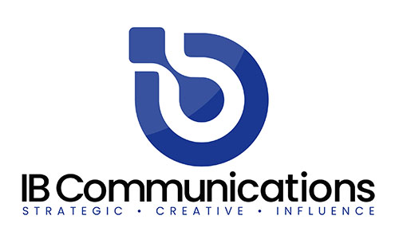
- FDA 2.0 and Organoids: What’s Next?,Tuesday, 18 Nov – 2:30pm: Led by Priya Baraniak, Chief Commercial & Development Officer at Pluristyx, this session examines regulatory evolution and its implications for organoid science. Pluristyx will also contribute to conversations on point-of-care manufacturing and strategic partnerships with CEO Benjamin Fryer, will be presenting on scalable platform manufacturing with iPSCs.
- Superdonors and Specialized Cells: Building a Reliable Pipeline for CGT, Wednesday, 19 Nov - Starting Materials in Decentralized Models Roundtable Discussion, hosted by BCAR (Blood & Cells Advocacy Roster) and moderated by Audrey Greenberg (Mayo Clinic), this session aims to explore the unique challenges and opportunities of building a reliable ‘superdonor’ network, emphasizing strategies to secure specialized donors who meet the exacting demands of CGT manufacturing while preserving the integrity of regional hubs and decentralized infrastructure.
- Next-Generation T-Cell Workflow: Activation, Transduction, and Expansion Wednesday, 19 Nov – Expert Panel Featuring Dr. Richard Koya (University of Chicago School of Medicine) alongside Trevor Smith and Dalip Sethi (Terumo BCT), this discussion will explore cutting-edge strategies for T-cell processing, with new data unveiled during the conference.
IBTV will showcase refreshed content formats designed to inform and engage:
- ‘On the Record’ – Short-form interviews with influential voices and emerging thinkers.
- ‘Roving Reporter’ – Real-time insights from the show floor, produced with The Medicine Maker.
- ‘360’ Panel Discussions – Editorially-driven roundtables offering depth, nuance, and debate.
These formats provide media outlets with compelling stories and shareable assets, while giving industry leaders a platform to speak directly to peers, partners, and the public.
Beyond the conference, IBTV leverages strategic media partnerships to ensure that the ideas generated in Philadelphia drive lasting impact. Combining journalistic rigor with innovative production, IBTV transforms moments into enduring movements.
[ENDS]
About IBTV
IBTV is a dedicated video and media platform for the life sciences industries, created to capture the authentic conversations and perspectives that don’t make it into press releases or polished marketing. We go beyond surface-level coverage to explore the themes shaping the future of life sciences, from emerging science to workforce challenges and patient impact.
Guided by collaboration and transparency, IBTV amplifies the voices of experts, innovators, and changemakers across the field. Our mission is simple: to deliver content built by the industry, for the industry – content that informs, engages, and endures.

