Press Release
Media Contact:
IB Communications
celltherapies@ibcomms.agency

Cell Therapies Supports Commencement of Australian Phase I/Ib Clinical Trial of A-SEEDS’ ACS2015 CAR-T Therapy for Solid Tumours

A-SEEDS Launch CARTiEr E312 Clinical Trial for ACS2015 Autologous CAR-T Cell Therapy Targeting EPHB4-Positive Solid Tumors

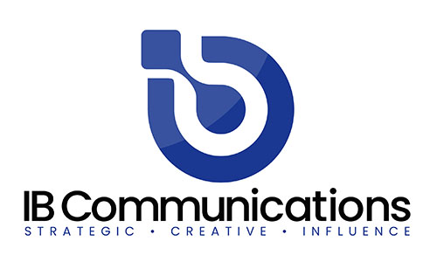
Cell Therapies is pleased to support the launch of the CARTiEr E312 Phase I/Ib clinical trial in Australia, evaluating A-SEEDS’ investigational CAR-T cell therapy, ACS2015, in patients with EPHB4-positive solid tumours.
The multicentre Australian study will assess the safety, tolerability, pharmacokinetics, pharmacodynamics and preliminary efficacy of ACS2015 across three challenging cancer indications: colorectal cancer, hepatocellular carcinoma, and bone and soft tissue sarcomas. The trial plans to enrol up to 48 patients.
ACS2015 is an autologous CAR-T cell therapy targeting EPHB4, a protein that is overexpressed in a range of solid tumour types and represents a promising therapeutic target. The therapy has been developed with a streamlined manufacturing process that enables production from cryopreserved patient-derived blood cells, providing greater flexibility in patient collection and manufacturing scheduling.
As the manufacturing partner for the study, Cell Therapies is responsible for the GMP manufacture of ACS2015 for patients enrolled in Australia. With more than two decades of experience in the development and manufacture of advanced cell therapies, Cell Therapies provides the specialised infrastructure, technical expertise and quality systems required to support complex clinical-stage cell therapy programs.
This collaboration with A-SEEDS highlights Cell Therapies’ commitment to enabling the advancement of innovative cell and gene therapies and supporting international biotechnology companies as they bring novel treatments into clinical development.
The CARTiEr E312 study forms part of A-SEEDS’ broader clinical pipeline of CAR-T therapies targeting both solid and haematological malignancies. In addition to ACS2015, A-SEEDS is advancing:

- AP8901, an EPHB4-targeted CAR-T therapy currently being evaluated in the Phase I CARTiEr E211 study for patients with Ewing sarcoma and other solid tumours in Japan.

- AS116, a CAR-T therapy targeting the GM-CSF receptor (GMR), currently being assessed in the Phase I/II CARTiEr G111 study for patients with acute myeloid leukaemia (AML) in Japan.

Further information about the Australian CARTiEr E312 study is available through the Australian New Zealand Clinical Trials Registry (ANZCTR):
https://www.anzctr.org.au/Trial/Registration/TrialReview.aspx?id=390315&isReview=true

