Press Release
Media Contacts:
IB Communications
Tel +44 (0)20 89434685
trakcel@ibcomms.agency

TrakCel announces launch of OCELLOS Core orchestration product for early-stage personalized cell therapy development

Cardiff, UK, May 25, 2023 - TrakCel, the leading and proven provider of cellular orchestration systems to the global cell and gene therapy (CGT) industry, today announces the launch of OCELLOS Core, its latest product in the OCELLOS range of leading advanced therapy orchestration products. TrakCel will make OCELLOS Core available to customers from end of July 2023.

OCELLOS Core has been designed specifically as a Chain of Identity (COI) platform for the cell and gene therapy (CGT) sector. It will be used primarily for early-stage autologous and personalized therapy CGT clinical trials.

The platform provides a first route for early clinical developers into automated COI tracking, offering an alternative to paper and spreadsheets. TrakCel has provided this solution that can be validated within a client’s quality processes. It also ensures that all patient records are captured in the same system from the very first patient.

This out of the box solution has been designed to be deployed quickly and cost effectively to meet the needs of early-stage clinical autologous therapies. The solution is pre-configured and fully tested which enables deployment within two to three weeks. The supporting documentation from the testing can be leveraged if applicable during validation.

OCELLOS Core will also have the ability to track key events that form the chain of custody and offer an audit trail of when key tasks were carried out and by whom. As with the other solutions within the OCELLOS family, the product has been designed to evolve with therapies as trials progress through their development phases and into commercial launch.

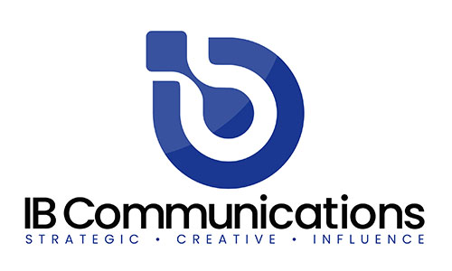
“As the CGT industry grows and matures, not only are there far more products going through clinical trials, but developers have realized that transitioning key regulatory requirements like COI management mid-way through clinical development is disruptive and costly. In addition, the headcount and collaboration needed to manually manage COI even at early stage can be surprisingly costly. This is why TrakCel has launched OCELLOS Core as a specific clinical-entry COI management solution,” said Paul Viggers, CCO, TrakCel. “TrakCel now has a full suite of orchestration products that are specifically tailored and costed to support therapy orchestration from early clinical trials, through to commercial launch.”

As part of the wider OCELLOS product family, the solution offers a user focused interface that can be supported by TrakCel with training and support packages to ensure that issues that could delay or interrupt patient treatment journeys are minimized and information still flows easily between key supply chain stakeholders.

The launch of OCELLOS Core, to join OCELLOS Lite and OCELLOS, also follows TrakCel’s integration of its ecosystem, with the widest range of partners across the cell and gene therapy supply chain. These 12 partners, scheduled to be 16 by the close of 2023, include couriers, CDMOs, clinical data system developers, patient hub services companies, and CGT labelling systems. As a result, TrakCel has the ability to manage and oversee all of the supply chain from the first clinical stages to post-commercialization.

End

About TrakCel
TrakCel is the market leading developer of integrated cell orchestration solutions. TrakCel has specifically designed these solutions to manage the international autologous and allogeneic cell, gene and immunotherapy value and supply chains. Its platform has evolved in collaboration with, and is increasingly adopted by, leading companies in the cell, gene and immunotherapy industries. TrakCel’s solutions enable real-time control for all organizations working across the entire therapeutic value chain. This control includes patient eligibility (commercial) and enrolment, sample collection, manufacturing and treatment delivery. The TrakCel platform accelerates global scale-up and scale-out of cell and gene therapy products, increasing efficiency and decreasing complexity, while safe-guarding Chain of Custody and Chain of Identity with a full electronic audit trail for administration compliance and traceability. TrakCel was founded in 2012. It's headquartered in Cardiff, UK with US offices in California. https://trakcel.com.

